

System Analysis and Design

ONLINE BLOOD BANK MANAGEMENT SYSTEM

Amira Ali

CS_35

Team Members:
ID | Student Name | Official E-mail | Level | Department | Section | Contribution
20201700033 | أحمد حسن حسن خطاب | 20201700033@cis.asu.edu.eg | 3 | Computer Science | 1 | We all worked in this task by several online meetings together.
20201700159 | انس سعيد صبري | 20201700159@cis.asu.edu.eg | 3 | Computer Science | 2
20191700875 | أحمد هاني حامد محمد | 20191700875@cis.asu.edu.eg | 3 | Computer Science | 1
20201700488 | عبدالرحمن هاني خيري | 20201700488@cis.asu.edu.eg | 3 | Computer Science | 5
20201700968 | هشام ايمن محمد ابراهيم | 20201700968@cis.asu.edu.eg | 3 | Computer Science | 10
20201701023 | يوسف عماد الدين مسعد علي | 20201701022@cis.asu.edu.eg | 3 | Computer Science | 10

Correct Version of Task 1 Diagrams
- Use Case Diagram
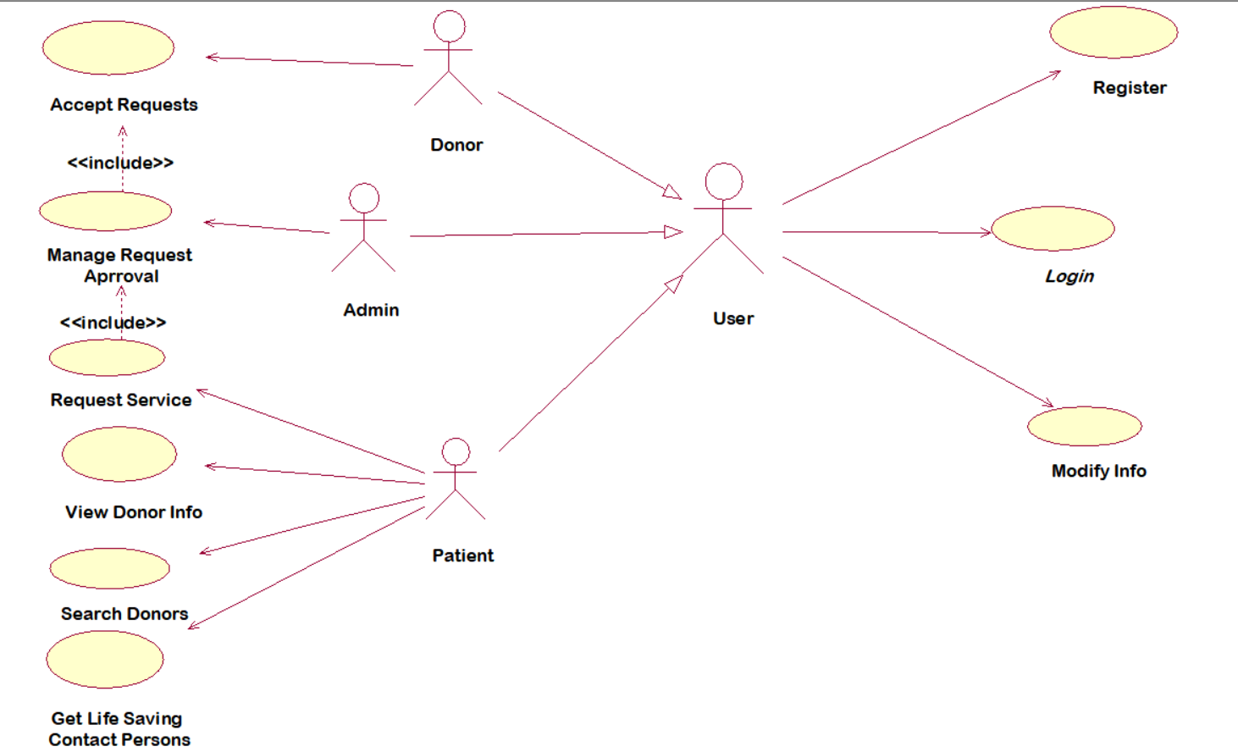

- DFD Diagrams
  - Context Diagram
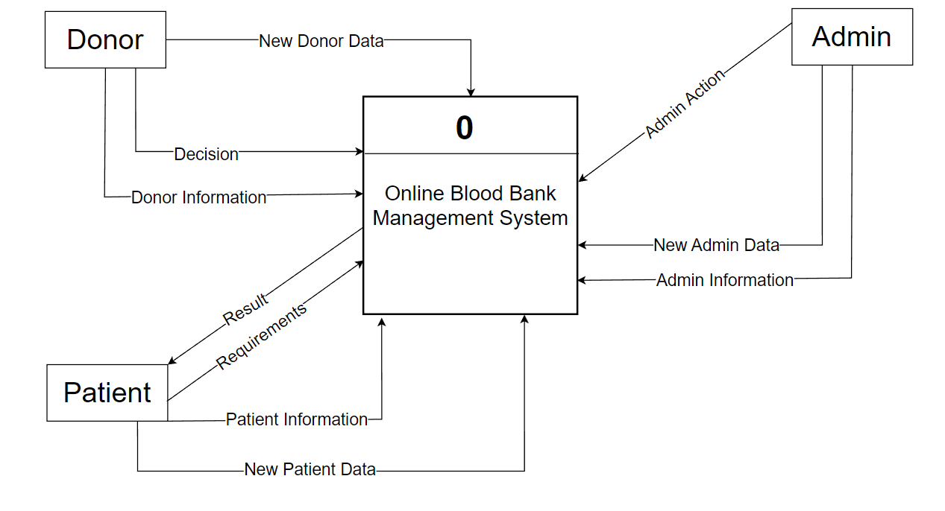
  - Level 0 Diagram
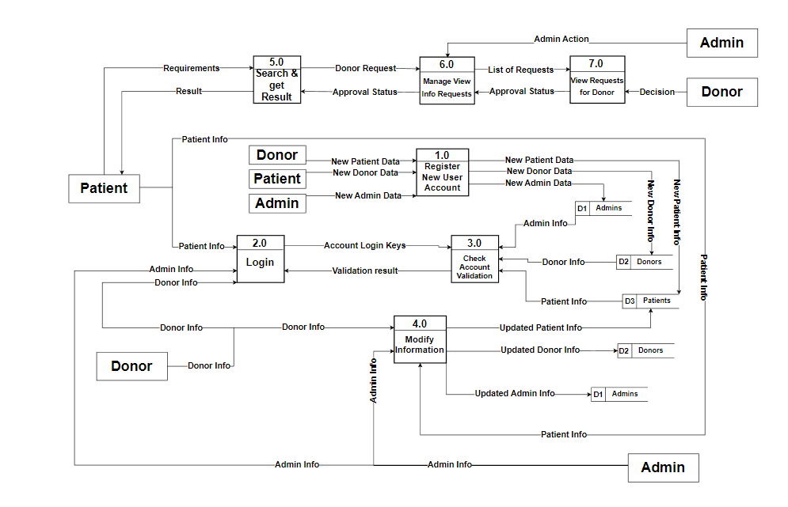
  - Level 1 Diagram

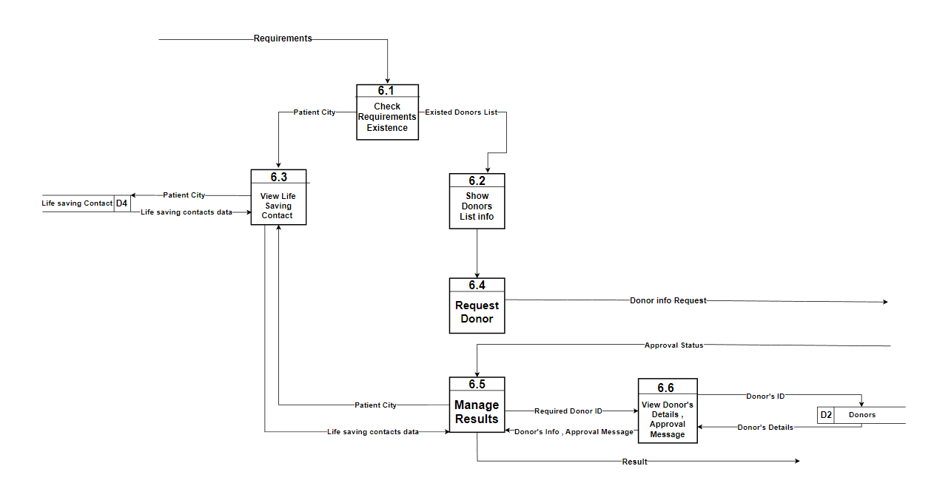
Task 2

- Class Diagram
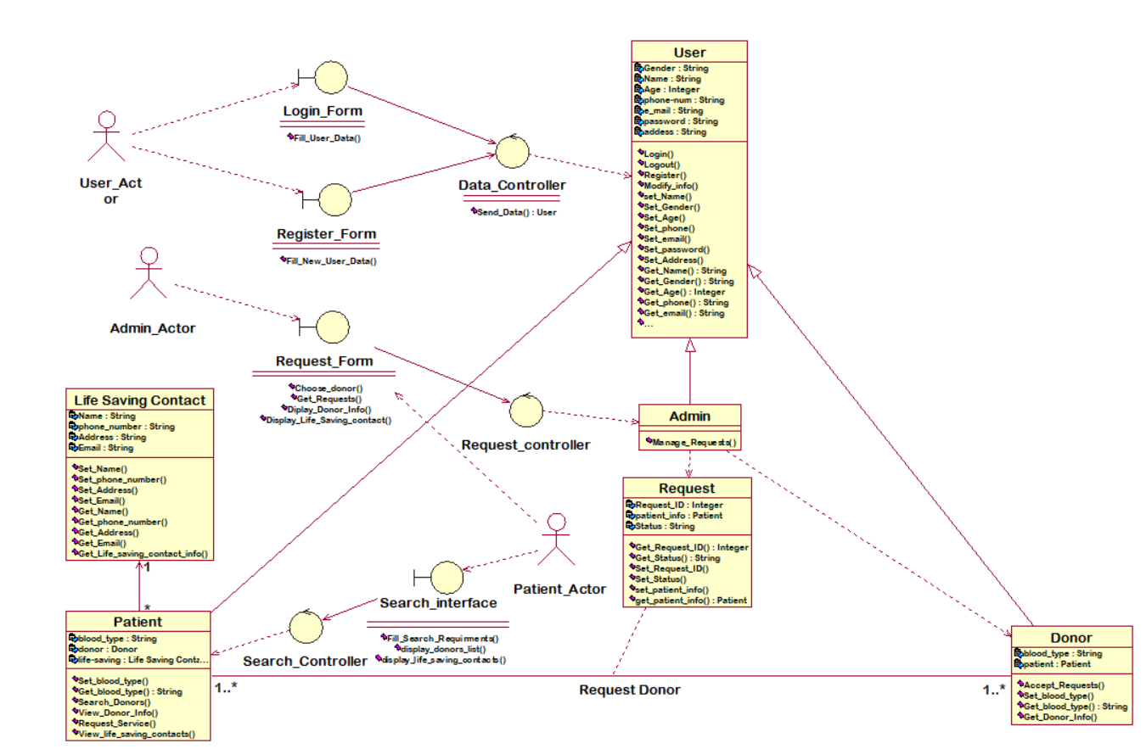
2.Sequence Diagrams

